**Name: Victoria Jacqueline Macías Pico**

**W O R K S H E E T S**

**NOTE:** **Your answers must be in blue and bold.**

# UNIT 11

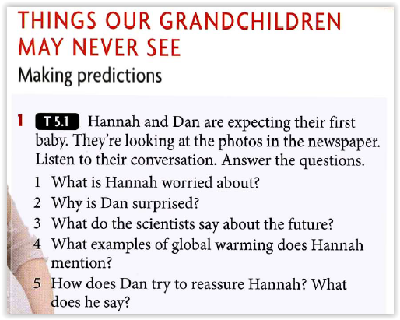

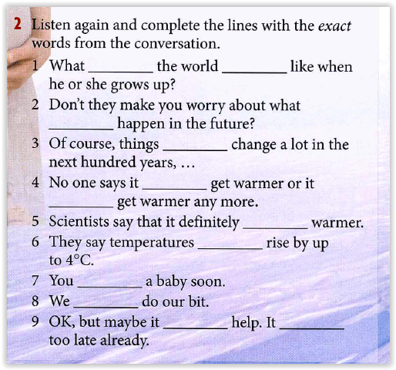

**will**

**be**

**could**

**are going to**

**may**

**might**

**will get**

**might**

**‘re having**

**‘ll**

**won't**

**may be**

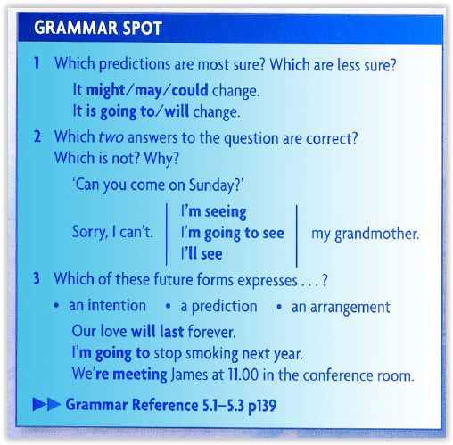

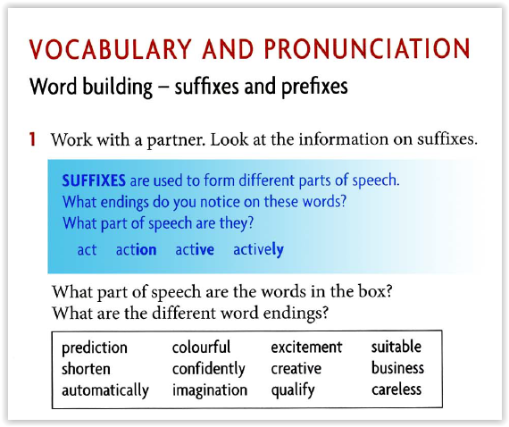

**Act = Verb**

**Action = Noun**

**Active = Adjective**

**Actively = Adverb**

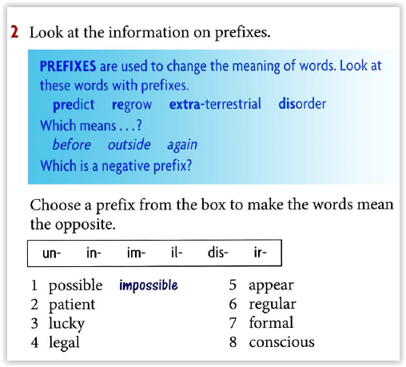

1. **Impossible**
2. **Impatient**
3. **Unlucky**
4. **Illegal**
5. **Disappear**
6. **Irregular**
7. **Informal**
8. **Unconscious**

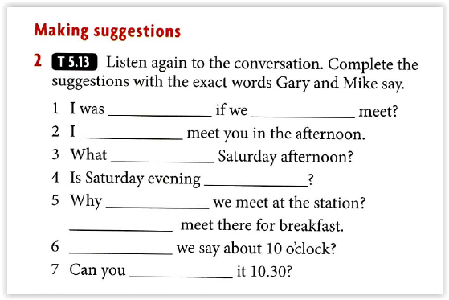

**wondering**

**could**

**could**

**about**

**any good**

**don’t**

**Let’s**

**Should**

**make**